Memorandum of Understanding

This Memorandum of Understanding (MOU), dated as of this 7th day of April, 2021, is entered into between MedInsight PRM Analytics (“MedInsight” or “PRM”) and Mountain Gulf Health (MGH) and sets forth the mutual intentions of PRM and MGH relating to the design, development, support of the DEPTH interface.

RECITALS
- PRM has the knowledge, experience and capacity to perform the task of designing and developing an interface for DEPTH; and

- MGH has defined the scope of DEPTH and developed a process and underlying data structures to feed the interface.

The terms and conditions that shall apply are described herein.
TERMS
- MGH will be responsible for providing the data and analytic outputs to support DEPTH.
- MGH will provide sales and marketing of the DEPTH product alongside the Health and Group Benefits practice (HGB).
- MGH will provide partner clients/contacts to assist with design and feedback.
- PRM will assist with user interviews to support DEPTH design.
- PRM will create design prototypes which MGH will approve prior to engineering work beginning.
- PRM will build the interface based on the approved design prototype.
- PRM will retain the rights to the code used in the DEPTH interface development.
- PRM will fix bugs in the interface as needed, feature enhancements and client requests will be scoped and scheduled upon request.
- PRM reserves the right to revisit the revenue share in the event of a substantial feature enhancement in the future (i.e. a new tab/view added to the dashboard).
- MGH will host DEPTH on the Milliman Access Portal (MAP) under the terms of the MAP MOU found in appendix A.
- DEPTH will not offer direct querying or data warehousing services.
- DEPTH can use GRVU outputs to support the analytics; however, GRVU outputs should not be directly provided to clients.
- DEPTH and MedInsight will be jointly sold and marketed as tools in the employer market, depending on the size and complexity of the client. Generally, smaller employer clients will be first offered DEPTH and larger clients will be offered MedInsight; however, this is subject to refinement after a period of market testing. As well. Offering DEPTH to a larger client may be an effective strategy to break loose their relationship with an existing competitor of MedInsight. If the employer client or representative requires ad hoc analytic capabilities, then they will be offered MedInsight.
- - MedInsight. MedInsight and DEPTH agree to add in market-proven DEPTH analytics/dashboards into MedInsight.

Revenue and Cost Share
When DEPTH is sold as a stand-alone product:
- PRM will receive 22.5% of the revenue generated by DEPTH
  - 12.5% for the design/development of the dashboard
  - 10% for use of the GRVUs
When DEPTH is sold as part of a MI license:
- MGH will receive 25% of the MedInsight license fees with a minimum fee of $5,000
- Any additional royalties owed for the use of other intellectual property utilized by DEPTH will be added to the cost of the lease and paid out of those funds (note this only applies in situations where the client does not already purchase those products as part of their MedInsight lease)

IN WITNESS WHEREOF, the Parties have executed this MOU as the data first written above.

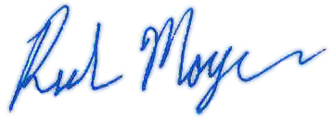
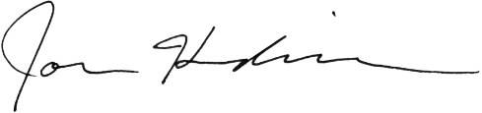
PRM Analytics Mountain Gulf Health
By: _____ ___________________ By:_________________ __________
Name:__Rich Moyer___________ Name:_Jon M. Hendrickson, FSA, MAAA
Title:__Principal______________ Title:_Principal and Consulting Actuary_

Appendix A

Memorandum of Understanding

This MEMORANDUM OF UNDERSTANDING, dated as of this 7th day of April, 2021 (this “MOU”), is entered into between MedInsight PRM Analytics (“PRM”) and the Mountain Gulf Health Practice of Milliman, Inc. (“MGH”) and sets forth the mutual intentions of PRM and MGH relating to content hosting and delivery through Milliman Access Portal (“MAP”).

RECITALS

- PRM has developed an application, MAP, and desires to make the same available to the licensee for delivery of content to the licensee’s client(s); and

- MGH has generated content for clients and would like to deliver this content through a secure web portal.

The terms and conditions that shall apply are described herein.

TERMS

- PRM will maintain relationships and license agreements with software vendors necessary to deploy and maintain MAP.

- PRM will maintain the infrastructure necessary to deploy and maintain MAP.

- PRM will be responsible for monitoring the system status of MAP and taking any necessary actions to ensure system stability and continuity of service.

- PRM will provide user support during regular business hours at map.support@milliman.com. Client-specific support requests will be forwarded to the appropriate contacts for MGH. Regular business hours are Monday through Friday 9am – 4pm ET.

- PRM will provide regular security and feature enhancements to MAP to maintain and improve the reliability and usability of the application.

- PRM will provide training and documentation to MGH staff for the purpose of ensuring proper management of MGH clients, content, and users.

- PRM will provide additional development assistance to MGH when necessary to ensure that content conforms to technical requirements for hosting in MAP. The billing rate for this service is $200 per hour.

- PRM will maintain records of all interactions with the application and content in order to provide a complete history of what was accessed, by whom, and when. This will be made available to MGH upon request.

- PRM will notify MGH of any scheduled maintenance windows for MAP.

- MGH must include PRM in the completion of security questionnaires from clients of MGH in regards to MAP. All time incurred by PRM staff in the process of completing questionnaires will be billed at a rate of $200 per hour.

- MGH must get approval from PRM on any contractual obligations relating to MAP before entering into the agreement.

- MGH shall designate at least one person who shall have responsibility to create and administer end user accounts for MGH’s hosted content.

- MGH accepts responsibility for the system privileges granted to users by MGH’s administrative users.

- MGH shall designate at least one contact person who shall have responsibility to support user inquiries relating directly to the hosted content.

- MGH shall designate at least one person to perform publishing of its content with MAP and to receive training to do the same. This person, or persons, shall be responsible for confirming the accuracy and appropriateness of content that is published on behalf of MGH and will be required to attest to this at time of publication.

- MGH will be invoiced quarterly based on the pricing structure available on the MAP Support site (https://indy-github.milliman.com/pages/MAP/#pricing). Annual price adjustments for the following year will be posted by October 31st and go into full effect on the following January 1st. As new content types are made available through future feature enhancements, these prices will be made available on the MAP Support site. Publishing content to MAP for any content type will be viewed as an implicit agreement to the published rates, and will be billed as such.

IN WITNESS WHEREOF, the Parties have executed this MOU as of the date first written above.

PRM Analytics Mountain Gulf Health Practice
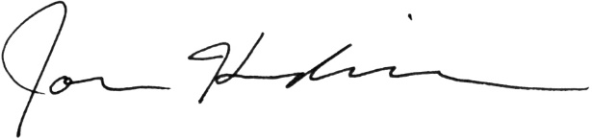

By: By:
Name: Rich Moyer Name: Jon M. Hendrickson, FSA, MAAA
Title: Principal Title: Principal and Consulting Actuary

